**Sunday Worship**

**Scots Church Adelaide**

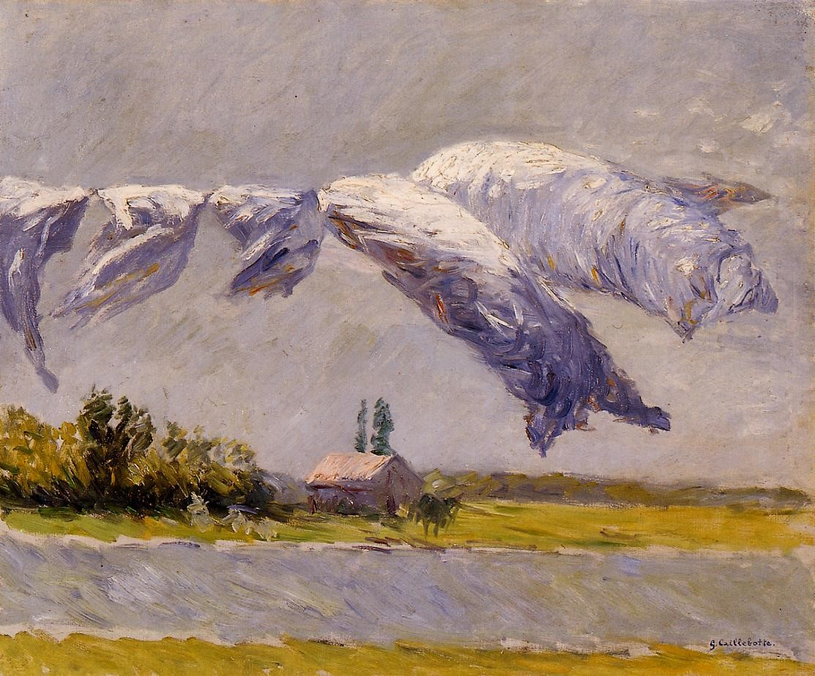

*The Mystical Supper*, Russian Orthodox [icon](https://en.wikipedia.org/wiki/Icon), 1497

Scots Church Adelaide is a welcoming,

inclusive, and worshipping community of God,

committed to justice, learning and care,

anticipating a world transformed by the love of God.

**Scots Church Adelaide acknowledges that we gather on Kaurna Country, and we pay respect to Elders past, present and emerging. We recognise and respect their culture, beliefs and relationship with the land.**

**Welcome**

An asterisk **\*** indicates that we stand as we are able.

We are invited to speak the words in ***bold* *italics*.**

*Helpful instructions and explanations are in italics*.

**If you require the hearing loop, please sit in the middle of the centre pews.**

**Meditation**

*Linen out to Dry, Petit Gennevilliers* (1888) by the French Impressionist painter Gustave Caillebotte might seem like a strange image to use for the famous story about the healing of ten men with a skin disease.

This skin disease not only damaged bodies but also relationships. If a person contracted a contagious skin disease in the first century, isolation from relationships and community was the only option.

Encountering Jesus, the ten were healed. Like the washing on the line, they were made clean, restored, refreshed; ready to be again who they were created to be.

The washing here looks ready to escape the line and fly. The ten were healed and made free—so free that one of them was free enough to ignore the injunction to visit the priest and return to Jesus.

**Prelude**

*The music of the prelude invites us to quieten our busy minds and prepare to worship.*

**\*Processing of the Bible**

*We stand and together bring the Bible to the centre of our worship service,*

*expecting to learn and be inspired.*

**Lighting the Candle**

*The candle’s flame represents the presence of God with us now and always.*

Then God said, “Let there be light,” and there was light.

***Light shining in the darkness***

The light of creation

***The light of the world***

(from the Book of Genesis: 10th–5th Century BCE

and the Gospel of John: late 1st century CE)

**Call to Worship**

*We remind ourselves that we are here to worship God together.*

God of Love, we come to worship you.

You are the Creator of this land and of all good things.

Our hope is in you because you gave your Son, Jesus

to reconcile the world to you.

We pray for your strength and grace

to forgive, accept and love one another, as you love us

and forgive and accept us in the sacrifice of your Son.

(Wontulp Bi-Buya Indigenous Theology Working Group: 20th century CE)

**\*A Hymn of Praise 152**

Joyful, joyful, we adore you,

God of glory, God of love;

hearts unfold like flowers before you

opening to the sun above.

Melt the clouds of sin and sadness,

drive the dark of doubt away;

giver of immortal gladness,

fill us with the light of day.

All your works with joy surround you,

earth and heav’n reflect your rays,

stars and angels sing around you,

centre of unbroken praise.

Field and forest, vale and mountain,

flowery meadow, flashing sea,

singing bird and flowing fountain

call to praise you joyfully.

You are giving and forgiving,

ever blessing, ever blest,

well-spring of the joy of living,

ocean-depth of happy rest.

You our Father, Christ our brother,

all are yours who live in love;

teach us how to love each other,

lift us to your joy above.

**Psalm 100**

*The Hebrew Psalms are an ancient collection of poems long used in Christian worship.*

Make a joyful noise to the Lord, all the earth.  
***Worship the Lord with gladness;***

come into God’s presence with singing.

***Know that the Lord is God.***

It is God who made us,  
***we are God’s people, and the sheep of God’s pasture.***

Enter God’s gates with thanksgiving,

***and God’s courts with praise.***

Give thanks to God, bless God’s name.

***For the Lord is good;***

God’s steadfast love endures forever,  
***and God’s faithfulness to all generations.***

(Psalm 100: 10th–5th century BCE)

**Prayer**

*This prayer acknowledges that God is with us and helps us experience God’s presence.*

O God, who instructs the hearts of the faithful

by the light of the Holy Spirit,

grant us in the same Spirit to be truly wise

and ever to rejoice in His consolation.

Through Christ our Lord.

***Come, Holy Spirit, fill the hearts of Your faithful,***

***and enkindle in them the fire of Your love.***

***Send forth Your Spirit and they shall be created.***

***And You shall renew the face of the earth.***

***Amen.***

(Veni, Sancte Spiritus: 13th century CE)

**Prayer of Confession**

*We are made in the image of God, but so often do not fully live this truth. We do much to damage ourselves and each other. In confession, we acknowledge these hard truths and open ourselves to God’s forgiveness, which comes to us abundantly.*

Before God, we confess:

***Creator God,***

God of the oceans, God of the land and all that is within it:

You created this world with the power of your word.  
You formed humankind with your own hands

and breathed your own breath into us.  
You gave us these lands as a gift–

a source of our identity and sustenance.  
you empowered us to be the stewards of what you have made.

***Loving God,***we have failed you and abused the gift you have given us.  
We have offended you and defiled what you have made.  
Forgive us for betraying your trust.  
Forgive us for our greed and arrogance.  
Forgive us for what we have done to your earth.  
Forgive us for what we have done to your oceans.  
Forgive us for what we have done to your creatures,  
on the land, in the sky and in the depths.

***Hear, O God of Compassion:***The cries of land have become desert;

land laid barren through corrupt agricultural practices,

pollution, mining and deforestation.  
The cries of islands drowning in the rising seas,   
The cries of distress from Mother Earth.

***God of Life,***heal your wounded earth.

Empower us to choose the road that leads to life.  
Guide us in the paths of righteousness for your name’s sake  
So that we may experience once again your Shalom

in the land and in the sea.  
This we ask in the name of the one who came

that we may have life in abundance,

your Son, our Saviour Jesus the Christ.

***Amen.***

(Rev. James Bhagwan, Fiji: 21st century CE)

**Assurance of Pardon and Renewal**

Sisters and brothers,

your life is held in God.

God knows where you are weak and where you are strong,

when you have been faithful and when you have failed.

God knows you. God loves you. God forgives you.

***Thanks be to God.***

**\*A Hymn of Thanks 596**

Fill my whole life, O Lord my God,

in every part with praise,

that my whole being may proclaim

your being and your ways.

Not for the lip of praise alone

nor ev’n the praising heart

I ask, but for a life made up

of praise in every part:

praise in the common things of life,

its goings out and in;

praise in each duty and each deed,

however small and mean.

Fill every part of me with praise:

let all my being speak

of you and of your love, O Lord,

poor though I be and weak.

So shall you, Lord, receive from me

the praise and glory due;

and so shall I begin on earth

the song for ever new.

So shall no part of day and night

from sacredness be free;

but with you, Lord, in every step

my fellowship will be.

**WE LISTEN FOR WHAT GOD IS SAYING TO US TODAY**

*In this part of our worship service, we pray that God might help us understand what we hear,*

*we listen to parts of the Bible, and a message exploring what those words might mean for us today.*

**Prayer for Illumination**

May these ancient texts be a lamp to our feet

and a light to our path.

(Psalm 119: 10th–5th Century BCE)

**The Psalm for the day**

*The Psalms express the full range of human emotions before God: joy, sorrow, praise, anger, trust, and repentance. We read the text on the screen in call and response.*

Make a joyful noise to God, all the earth;

***sing the glory of God’s name;***

give to God glorious praise.  
***Say to God, “How awesome are your deeds!***

Because of your great power, your enemies cringe before you.

All the earth worships you;  
 ***they sing praises to you,***

***sing praises to your name.***

Come and see what God has done:  
***God is awesome in deeds among mortals.***

Bless our God, O peoples;  
***let the sound of God’s praise be heard,***

who has kept us among the living  
***and has not let our feet slip.***

For you, O God, have tested us;

***you have tried us as silver is tried.***

Come and hear, all you who fear God,  
***and I will tell what God has done for me.***

I cried aloud to God

***and God was extolled with my tongue.***

If I had cherished iniquity in my heart,  
**the Lord would not have listened.**

But truly God has listened;  
***God has heard the words of my prayer.***

Blessed be God,  
***who has not rejected my prayer  
or removed God’s steadfast love from me.***

**The Good News for today**

**Jeremiah 29:1, 4-7**

29:1These are the words of the letter that the prophet Jeremiah sent from Jerusalem to the remaining elders among the exiles and to the priests, the prophets, and all the people whom Nebuchadnezzar had taken into exile from Jerusalem to Babylon.

29:4Thus says the LORD of hosts, the God of Israel, to all the exiles whom I have sent into exile from Jerusalem to Babylon:

29:5Build houses and live in them; plant gardens and eat what they produce.

29:6Take wives and have sons and daughters; take wives for your sons, and give your daughters in marriage, that they may bear sons and daughters; multiply there, and do not decrease.

29:7But seek the welfare of the city where I have sent you into exile, and pray to the LORD on its behalf, for in its welfare you will find your welfare.

In sacred words of old,

***we have heard the Spirit speak anew.***

**Homily**

**The Good News for today**

**Luke 17:11-19**

17:11On the way to Jerusalem Jesus was going through the region between Samaria and Galilee.

17:12As he entered a village, ten with a skin disease approached him. Keeping their distance,

17:13they called out, saying, "Jesus, Master, have mercy on us!"

17:14When he saw them, he said to them, "Go and show yourselves to the priests." And as they went, they were made clean.

17:15Then one of them, when he saw that he was healed, turned back, praising God with a loud voice.

17:16He prostrated himself at Jesus's feet and thanked him. And he was a Samaritan.

17:17Then Jesus asked, "Were not ten made clean? So where are the other nine?

17:18Did none of them return to give glory to God except this foreigner?"

17:19Then he said to him, "Get up and go on your way; your faith has made you well."

In sacred words of old,

***we have heard the Spirit speak anew.***

**Homily**

**Reflection:** 4th Sonata 1st and 2nd movements – Pepusch

*A moment, aided by music, to reflect on what we have heard and said in our worship together.*

**WE RESPOND IN FAITH**

*In this part of our worship service, we commit ourselves to live out the message of love that we have heard.*

**\*A Hymn of Dedication 473**

Community of Christ

Who make the Cross your own

Live out your creed and risk your life

For God alone

The God who wears your face

To whom all worlds belong

Whose children are of every race

And every song

Community of Christ

Look past the Church's door

And see the refugee the hungry

And the poor

Take hands with the oppressed

The jobless in your street

Take towel and water that you wash

Your neighbour's feet

Community of Christ

Through whom the word must sound

Cry out for justice and for peace

The whole world round

Disarm the powers that war

And all that can destroy

Turn bombs to bread and tears of anguish

Into joy

When menace melts away

So shall God's will be done

The climate of the world be peace

And Christ its sun

Our currency be love

And kindliness our law

Our food and faith be shared as one

For evermore

**Prayers of the People**

*We pray for our world, and we pray the prayer that Jesus taught to his disciples.*

Let us pray:

For peace in our world,

peace for the broken-hearted,

peace for the despairing.

***Let us pray to the Lord***

[SILENCE]

For peace in our world,

for peace in our land,

for peace in our homes,

***Let us pray to the Lord***

[SILENCE]

Peace for those who have died,

peace for those who mourn,

peace for the lonely and lost.

***Let us pray to the Lord***

[SILENCE]

For peace in our minds,

for peace in our hearts,

for peace in our souls.

***Let us pray to the Lord***

[SILENCE]

For forgiveness,

generosity and love

among all people everywhere,

and for the coming kingdom of peace,

***We pray to the Lord.***

Amen.

(Anglican Book of Common Prayer: early 20th century CE)

**The Lord’s Prayer**

Let us pray:

***Our Father in Heaven***

***hallowed be your name,***

***your kingdom come,***

***your will be done,***

***on earth as in heaven.***

***Give us today our daily bread.***

***Forgive us our sins,***

***as we forgive those who sin against us.***

***Save us from the time of trial***

***and deliver us from evil.***

***For the kingdom, the power, and the glory***

***are yours, now and forever. Amen.***

(Matthew 6:9-13: 1st century CE)

**Invitation to the Offering**

*One practical way of responding to God’s love is to contribute money to help others in need.*

We are, each of us, the gift of God in the world.

Let us give of ourselves in joy.

Our offering will now be received.

**\*Prayer of Dedication**

*We bring our offerings to God and pray that they might be used wisely.*

God of goodness and mercy,

we thank you that you invite us to participate

in the work of mercy and the building of justice.

May all that we give, money, time, energy

be gift in the world.

***Amen.***

**\*A Hymn of Commissioning 665**

Jesus Christ is waiting,

waiting in the streets;

no-one is his neighbour,

all alone he eats.

Listen, Lord Jesus,

I am lonely too.

Make me, friend or stranger,

fit to wait on you.

Jesus Christ is raging,

raging in the streets,

where injustice spirals

and real hope retreats.

Listen, Lord Jesus,

I am angry too.

In the Kingdom’s causes

let me rage with you.

Jesus Christ is healing,

healing in the streets;

curing those who suffer,

touching those he greets.

Listen, Lord Jesus,

I have pity too.

Let my care be active,

healing just like you.

Jesus Christ is dancing,

dancing in the streets,

where each sign of hatred

he, with love, defeats.

Listen, Lord Jesus,

I should triumph too.

Where good conquers evil

let me dance with you.

Jesus Christ is calling,

calling in the streets,

‘Who will join my journey?

I will guide their feet.’

Listen, Lord Jesus,

let my fears be few.

Walk one step before me;

I will follow you.

**LIFE AND MINISTRY OF OUR COMMUNITY**

*We share news about our life together in community.*

**WE GO IN FAITH**

*Our worship together now moves from this service and this place out into our hours and our days.*

*We continue to make community amongst us by hearing the Blessing, passing the peace and moving to the hall to share tea, coffee, and conversation.*

*If you are visiting with us, we invite you to join us this morning.*

*If you need to go, we understand.*

*You may wish to sign our visitors’ book as you leave.*

**\*Creed**

*A creed expresses things we believe are true. We speak it aloud*

*to remind ourselves of our calling and to embed it in our lives.*

We believe

***that every human being is made in the image and likeness of God***

***and possesses a dignity and value which can never be taken away.***

We believe

***that as children of the one God***

***we are one family with mutual responsibility for each other***

(Cardinal Basil Hume: late 20th century CE)

**\*Passing the Peace**

*We send each other out into our day in peace.*

Peace be with you. ***And also with you***

**\*Blessing**

*The Blessing reassures us that God is with us.*

Go forth into the world in peace;be of good courage;hold fast that which is good;render to no one evil for evil;strengthen the faint-hearted;support the weak;help the afflicted;honour all people;love and serve the Lord,rejoicing in the power of the Holy Spirit.***Amen.***

(St. Chrysostom, The Anglican Book of Common Prayer: 20th century CE)

**Choral Amen** TiS 783 (ii)

**\*Processing the Bible**

*Please remain standing as you are able for the processing of the Bible.*

**Postlude**

*Before we go, we invite you to sit in contemplation as we hear the Postlude.*

Sources used in worship today as noted through worship booklet.

Music reproduced with permission licenses #604419-A, *OneLicense,*

and #496838&#352810, *CCLI*. Image: Page 1, Gustave Caillebotte, *Linen out to Dry, Petit Gennevilliers* (1888).

**About Scots Church Adelaide**

Scots Church Adelaide began in 1851, formed by local supporters of the Free Church, a reform movement in the Church of Scotland that opposed political control of the church and engaged with the social changes of the 1800s, including industrialisation and urbanisation.

The church was originally named after the leader of the movement, Thomas Chalmers.

In 1865, Chalmers Free Church joined congregations of the Church of Scotland, the United Presbyterians, and the Free Church to form the Presbyterian Church of South Australia.

In 1929, the Chalmers congregation amalgamated with the Presbyterian congregation in Flinders St and took the name Scots Church Adelaide. After the church building in Flinders St was demolished, items including the organ, windows and plaques were installed in Scots Church, and the Flinders St stonework was re-used as facing for our office block.

In 1977, most of the Presbyterian Church of Australia joined with the Methodist Church of Australasia and the Congregational Church of Australia to form the Uniting Church in Australia. So, Scots Church Adelaide became a Uniting Church congregation.

Over the years, the congregation has supported many social initiatives. Today, Scots continues its commitment to the city community as a neighbour and place open to all. We host community organisations, including the SA Jazz Archive and The Big Issue. Our facilities are available for use by other community groups.

The building is the second oldest church still standing in the city. The current ministers are Rev Paul Turley, Minister of the Congregation, and Rev Jill Lienert, Minister for Community Connections. Worship services are held at 10.30am each Sunday.



**SCOTS CHURCH ADELAIDE**

**Uniting Church in Australia**

Kaurna Country 237 North Terrace, Adelaide

Ministers: Rev Paul Turley, Rev Jill Lienert

Phone 8223 1505 www.scotschurch.org

 www.facebook.com/scotschurchadelaide