Communion Sunday

Scots Church Adelaide

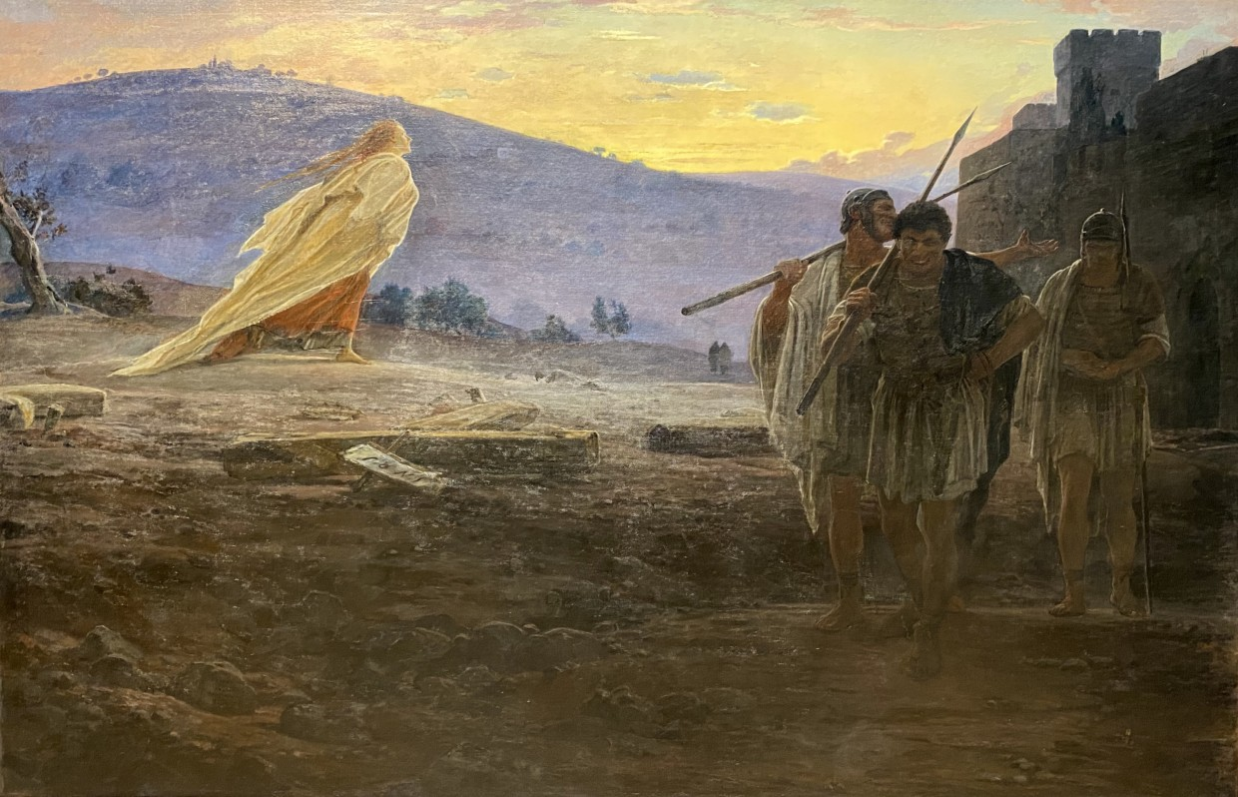

Easter Day
Sunday 5 April 2026

Scots Church Adelaide is a welcoming,
inclusive, and worshipping community of God,
committed to justice, learning and care,
anticipating a world transformed by the love of God.

Please sit in the pews marked with the white bows
to facilitate the serving of Communion

Scots Church Adelaide acknowledges that we gather on Kaurna Country, and we pay respect to Elders past, present and emerging. We recognise and respect their culture, beliefs and relationship with the land.

Welcome

An asterisk * indicates that we stand as we are able.
We are invited to speak the words in bold italics.
Helpful instructions and explanations are in italics.
If you require the hearing loop, please sit in the middle of the centre pews.

Meditation
The gospels do not tell us about the resurrection, only what happens afterwards. In Nikolay Ge's Heralds of the Resurrection (1867), Mary runs from the tomb toward the dawn.

The Roman soldiers in darkness, are they leaving the tomb or the crucifixion site after their change? We can only guess. For now, the great event of the resurrection is completely passing them by. But the dawn is coming. The light of the new day, yet to reach them, will soon be the light of all people (John 1:4)

Mary, having met the risen Jesus, is running from the tomb toward the dawn, away from death and into life. Her robes, golden in the morning light, stream behind her; she could be a bird about to take flight and soar.

Prelude

The music of the prelude invites us to quieten our busy minds and prepare to worship.

*Processing of the Bible

We stand and together bring the Bible to the centre of our worship service,
expecting to learn and be inspired.

Lighting the Candle

The candle’s flame represents the presence of God with us now and always.

Then God said, “Let there be light,” and there was light.
Light shining in the darkness

The light of creation
The light of the world

(from the Book of Genesis: 10th–5th Century BCE
and the Gospel of John: late 1st CE)

Call to Worship

We remind ourselves that we are here to worship God together.

Creator God, we are here, together in hope!
With community and creation

With neighbours near and far
With those known and new
Together in hope!
(from the Southern Asian Initiative of the
United Church of Christ: early 21st century CE)

*A Hymn of Praise 370 Christ the Lord is risen today

1. Christ the Lord is risen today:
Hallelujah!
Let the whole creation say:
Hallelujah!
Raise your joys and triumphs high,
Hallelujah!
Sing now, heaven and earth reply.
Hallelujah!

2. Love's redeeming work is done;
fought the fight, the battle won;
vain the stone, the watch, the seal:
Christ has burst the gates of hell.

3. Lives again our glorious king;
where, O death, is now thy sting?
Once he died, our souls to save;
Where your victory, O grave?

4. Soar we now where Christ has led,
following our exalted Head;
made like him, like him we rise:
ours the cross, the grave, the skies.

Psalm 100

The Hebrew Psalms are an ancient collection of poems long used in Christian worship.

Make a joyful noise to the Lord, all the earth.
Worship the Lord with gladness;

come into God’s presence with singing.
Know that the Lord is God.
It is God who made us,
we are God’s people, and the sheep of God’s pasture.

Enter God’s gates with thanksgiving,
and God’s courts with praise.

Give thanks to God, bless God’s name.
For the Lord is good;
God’s steadfast love endures forever,
and God’s faithfulness to all generations.

(Psalm 100: 10th–5th Century BCE)

Prayer

This prayer acknowledges that God is with us and helps us experience God’s presence.

Ever-living God,
you are infinite, yet compassionate;
in you we live, and move, and have our being.
One with us in Jesus Christ,
you share our life and our death;
flowing through us as living water,
you quench our thirst.
Holy One, we adore you;
Holy Wisdom, we adore you;
Holy Spirit, we adore you;
accept the praise we bring today and for ever.
Amen.
(Uniting Church in Australia: 21st century CE)

Prayer of Confession

We are made in the image of God, but so often do not fully live this truth. We do much to damage ourselves and each other. In confession, we acknowledge these hard truths and open ourselves to God’s forgiveness, which comes to us abundantly.

Before God, we confess in silence:

God of love,

We acknowledge our need for transformation and for grace.

We confess that we have not always lived as your beloved community,
called to embody justice, love, and radical hospitality.

Forgive us and set us free.
We confess that we have remained silent in the face of injustice,
that we have failed to see your image in every person

Forgive us and set us free.

We confess that we have built walls instead of bridges,
excluded rather than welcomed,
and chosen fear over love.

Forgive us and set us free.

We confess our failure to care for your creation with reverence.
We have consumed without consideration,
we have prioritised profit over the planet,
we have forgotten our call to be stewards of this sacred earth.

Forgive us and set us free.

As we share the communion meal together,
we confess our hunger—not just for bread and wine,
but for goodness, and for peace;
for a world where all may feast at tables of abundance and dignity.

Forgive us and set us free.
Forgive us and set us free.
Amen

(Uniting Church in Australia: 21st century CE)

Assurance of Pardon and Renewal

Friends, here is good news:
The goodness of God covers the world
as the waters cover the sea.
We are forgiven and set free
Thanks be to God.

(Uniting Church in Australia: 21st century CE)

*A Hymn of Thanks 209 And can it be

1. And can it be that I should gain
an interest in the Saviour's blood?
Died he for me, who caused his pain –
For me, who him to death pursued?
Amazing love! how can it be
that thou, my God, shouldst die for me!

2. ‘Tis mystery all! The immortal dies:
who can explore this strange design?
In vain the first-born seraph tries
to sound the depths of love divine.
‘Tis mercy all! Let earth adore,
let angel minds inquire no more.

3. He left his Father's throne above
(so free, so infinite his grace!),
emptied himself of all but love,
and bled for Adam's helpless race.
'tis mercy all, immense and free;
for, O my God, it found out me.

4. Long my imprisoned spirit lay
fast bound in sin and nature's night:
thine eye diffused a quickening ray –
I woke, the dungeon flamed with light!
My chains fell off, my heart was free,
I rose, went forth, and followed thee.

5. No condemnation now I dread:
Jesus, and all in him, is mine!
Alive in him, my living Head,
and clothed in righteousness divine,
bold I approach the eternal throne,
and claim the crown, through Christ, my own.

WE LISTEN FOR WHAT GOD IS SAYING TO US TODAY

In this part of our worship service, we pray that God might help us understand what we hear, we listen to parts of the Bible, and a message exploring what those words might mean for us today.

Prayer for Illumination

May these ancient texts be a lamp to our feet
and a light to our path.

(Psalm 119: 10th – 5th century BCE)

An Introduction to the Bible readings

The Psalm for the day

The Psalms express the full range of human emotions before God: joy, sorrow, praise, anger, trust, and repentance. We read the text on the screen in call and response.

Psalm 118:1-2, 14-24
O give thanks to the Lord, for he is good; his steadfast love endures for ever!
Let Israel say, 'His steadfast love endures for ever.'

The Lord is my strength and my might; he has become my salvation. There are glad songs of victory in the tents of the righteous:

'The right hand of the Lord does valiantly;
the right hand of the Lord is exalted;
the right hand of the Lord does valiantly.'
I shall not die, but I shall live, and recount the deeds of the Lord.

The Lord has punished me severely, but he did not give me over to death.
Open to me the gates of righteousness, that I may enter through them and give thanks to the Lord.

This is the gate of the Lord; the righteous shall enter through it.
I thank you that you have answered me and have become my salvation.

The stone that the builders rejected has become the chief cornerstone. This is the Lord's doing; it is marvellous in our eyes.

This is the day that the Lord has made;
let us rejoice and be glad in it.

The Good News for today

Jeremiah 31:1-6

31 At that time, says the Lord, I will be the God of all the families of Israel, and they shall be my people.
² Thus says the Lord:
The people who survived the sword
found grace in the wilderness;
when Israel sought for rest,
³ the Lord appeared to him from far away.
I have loved you with an everlasting love;
therefore I have continued my faithfulness to you.
⁴ Again I will build you, and you shall be built,
O virgin Israel!
Again you shall adorn yourself with your tambourines
and go forth in the dance of the merrymakers.
⁵ Again you shall plant vineyards
on the mountains of Samaria;
the planters shall plant
and shall enjoy the fruit.
⁶ For there shall be a day when sentinels will call
in the hill country of Ephraim:
“Come, let us go up to Zion,
to the Lord our God.”

Matthew 28:1-10

28 After the Sabbath, as the first day of the week was dawning, Mary Magdalene and the other Mary went to see the tomb. ² And suddenly there was a great earthquake, for an angel of the Lord, descending from heaven, came and rolled back the stone and sat on it. ³ His appearance was like lightning and his clothing white as snow. ⁴ For fear of him the guards shook and became like dead men. ⁵ But the angel said to the women, “Do not be afraid, for I know that you are looking for Jesus who was crucified. ⁶ He is not here, for he has been raised, as he said. Come, see the place where he lay. ⁷ Then go quickly and tell his disciples, ‘He has been raised from the dead, and indeed he is going ahead of you to Galilee; there you will see him.’ This is my message for you.” ⁸ So they left the tomb quickly with fear and great joy and ran to tell his disciples. ⁹ Suddenly Jesus met them and said, “Greetings!” And they came to him, took hold of his feet, and worshiped him. ¹⁰ Then Jesus said to them, “Do not be afraid; go and tell my brothers and sisters to go to Galilee; there they will see me.”

In sacred words of old,
we have heard the Spirit speak anew.

Sermon

Reflection:

A moment, aided by music, to reflect on what we have heard and said in our worship together.

WE RESPOND IN FAITH

In this part of our worship service, we commit ourselves to live out the message of love that we have heard.
*A Hymn of Dedication 392 At the dawning of salvation

1. At the dawning of salvation;
in the morning of the world,
Christ is raised, a living banner
by the love of God unfurled,
Through the daylight, through the darkness,
Christ leads on his great array:
all the saints and all the sinners
he has gathered on his way.
2. He is risen in the morning,
he is risen from the dead;
he is laughter after sadness,
he is light when night has fled.
He has suffered, he has triumphed,
life is his alone to give:
as he gave it once he gives it
evermore, that we may live.
3. For the glory of salvation
in the dawn of Easter day
we will praise you, loving Father;
we rejoice to sing and pray
with the Son and with the Spirit
Lead us on, your great array,
saints and sinners celebrating
your triumphant love today.

Prayers of the People

We pray for our world, and we pray the prayer that Jesus taught to his disciples.

God of all goodness and compassion,
as we gather around this table of abundance,
we remember that your love knows no boundaries,
your grace excludes no one,
and your table welcomes all who hunger for justice and peace.

We pray for your church in all its beautiful diversity—
may we embody the radical hospitality of Christ,
breaking down walls that divide,
opening doors that have been closed,
and setting tables where all your beloved children find nourishment.

We pray for all who hold positions of power and influence.
Grant them wisdom to govern with compassion,
courage to speak truth to injustice,
and humility to listen to the voice of justice.

We pray for those who are hungry— those who are refugees,
and those who are unemployed and underemployed.

We pray for those facing discrimination, violence, or exclusion
because of who they are or whom they love.

As we take bread and wine, fruits of the earth and work of human hands,
we acknowledge our interconnectedness with all creation.
Inspire us to live sustainably, to protect the climate,
and to ensure that future generations inherit a world of beauty and abundance.
God of love, transform us, as we receive this sacred meal.
May the bread strengthen us for the work of justice,
and may the cup fill us with courage to love boldly.

In the name of Christ, we pray.

Amen.

(Uniting Church in Australia: 21st century CE)

The Lord’s Prayer

Let us pray:

Our Father in Heaven
hallowed be your name,
your kingdom come,
your will be done,
on earth as in heaven.
Give us today our daily bread.
Forgive us our sins,
as we forgive those who sin against us.
Save us from the time of trial
and deliver us from evil.
For the kingdom, the power, and the glory
are yours, now and forever. Amen.

(Matthew 6:9-13: 1st century CE)

Invitation to the Offering

One practical way of responding to God’s love is to contribute money to help others in need.

When we share what we have been given,
we share in the great relationship at the heart of God.

Our offering will now be received.

*Prayer of Dedication

We bring our offerings to God and pray that they might be used wisely.

Loving God,
receive our gifts.
All we have comes from you.
May what we give
be for the hope of the world.
Amen.

COMMUNION

In this part of our worship service, we share the ancient symbolic meal often called the Eucharist, the Lord’s Supper or the Mass. Together we share small amounts of bread and grape juice as a sign of God’s goodness in creation and of God welcoming us into new life through the life, death, and resurrection of Jesus.
Scots Church Adelaide welcomes all people to participate in the sacrament of communion. Bread and grape juice are distributed to us in our seats.
Gluten-free bread will be available.

The Peace
The peace of the Lord be always with you.
And also with you.

Invitation
This is the joyful feast of Jesus…
…and calls you God’s own.

Prayer of Approach
Be present, risen Lord Jesus…

Narrative of the Institution of the Lord’s Supper
Hear the words of institution of this sacrament as recorded by the apostle Paul…

Great Prayer of Thanksgiving
The Lord be with you.
And also with you.
Lift up your hearts.
We lift them to the Lord.
Let us give thanks to the Lord our God.
It is right to give our thanks and praise.
With all we are, we give you glory, Trinity of love…
… as we join the company of heaven in their song.
Hymn: TiS 761 Holy, holy
Holy, holy, holy Lord, God of power and might,
Heaven and earth are full of your glory.
Hosanna in the highest.
Blessed is the one who comes
in the name of the Lord.
Hosanna in the highest.
To Adam and Eve, children of dust…

…Through him, in him and because of him, we affirm the Church’s faith:

Christ has died.
Christ is risen.
Christ will come again.
And so, in remembrance of all you have done for us…
…we worship you in joyful song:

Blessing and honour and glory and power are yours for ever and ever. Amen.

The Breaking of The Bread
Christ is the bread of joy……let us become what we receive.
The body of Christ.
Lamb Of God
Jesus, Wisdom of God,
have mercy on us.
Jesus, Word made flesh
have mercy on us.
Jesus, Liberator of creation,
grant us peace.
The Communion
Receive this holy sacrament…

Prayer After Communion
God of heaven and earth…
…In Christ’s name.
Amen

*A Hymn of Commissioning 380 Yours be the glory

1. Yours be the glory, risen, conquering Son;
endless is the victory over death you’ve won;
angels in bright raiment rolled the stone away,
kept the folded grave clothes, where thy body lay.

Yours be the glory, risen, conquering Son,
endless is the victory over death you’ve won.

2. See, Jesus meets us, risen from the tomb;
lovingly he greets us, scatters fear and gloom;
let the church with gladness hymns of triumph sing.
for the Lord is living, death has lost its sting.
Refrain

3. No more we doubt you, glorious Prince of life;
life is nought without you: aid us in our strife;
make us more than conquerors through thy deathless love;
Bring us safe through Jordan to your home above.
Refrain

LIFE AND MINISTRY OF OUR COMMUNITY

We share news about our life together in community.

WE GO IN FAITH

Our worship together now moves from this service and this place out into our hours and our days.

We continue to make community amongst us by hearing the Blessing, passing the peace and moving to the hall to share tea, coffee, and conversation.

If you are visiting with us, we invite you to join us this morning.
If you need to go, we understand.

You may wish to sign our visitors’ book as you leave.

*Affirmation

An affirmation expresses things we believe are true. We speak it aloud
to remind ourselves of our calling and to embed it in our lives.

We believe
that every human being is made in the image and likeness of God
and possesses a dignity and value which can never be taken away.

We believe
that as children of the one God
we are one family with mutual responsibility for each other

(Cardinal Basil Hume: late 20th century CE)

*Passing the Peace

We send each other out into our day in peace.

Peace be with you. And also with you

*Blessing

The Blessing reassures us that God is with us.

Go forth into the world in peace;
be of good courage;
hold fast that which is good;
render to no one evil for evil;
strengthen the faint-hearted;
support the weak;
help the afflicted;
honour all people;
love and serve the Lord,
rejoicing in the power of the Holy Spirit.
Amen.
(St. Chrysostom, The Anglican Book of Common Prayer: 20th century CE)

Choral Amen TiS 783 (ii)

*Processing the Bible
Please remain standing as you are able for the processing of the Bible.

Postlude
Before we go, we invite you to sit in contemplation as we hear the Postlude.

There will be a retiring offering for Parish Relief.
Offering plates are located at the back of the church

Sources used in worship today as noted through worship booklet.
Music reproduced with permission licenses #604419-A, OneLicense,
and #496838&#352810, CCLI. Image: Nikolay Ge, Heralds of the Resurrection (1867).

About Scots Church Adelaide

Scots Church Adelaide began in 1851, formed by local supporters of the Free Church, a reform movement in the Church of Scotland that opposed political control of the church and engaged with the social changes of the 1800s, including industrialisation and urbanisation.

The church was originally named after the leader of the movement, Thomas Chalmers.

In 1865, Chalmers Free Church joined congregations of the Church of Scotland, the United Presbyterians, and the Free Church to form the Presbyterian Church of South Australia.

In 1929, the Chalmers congregation amalgamated with the Presbyterian congregation in Flinders St and took the name Scots Church Adelaide. After the church building in Flinders St was demolished, items including the organ, windows and plaques were installed in Scots Church, and the Flinders St stonework was re-used as facing for our office block.

In 1977, most of the Presbyterian Church of Australia joined with the Methodist Church of Australasia and the Congregational Church of Australia to form the Uniting Church in Australia. So, Scots Church Adelaide became a Uniting Church congregation.

Over the years, the congregation has supported many social initiatives. Today, Scots continues its commitment to the city community as a neighbour and place open to all. We host community organisations, including the SA Jazz Archive and The Big Issue. Our facilities are available for use by other community groups.

The building is the second oldest church still standing in the city. The current ministers are Rev Paul Turley, Minister of the Congregation, and Rev Jill Lienert, Minister for Community Connections. Worship services are held at 10.30am each Sunday.



SCOTS CHURCH ADELAIDE
Uniting Church in Australia
Kaurna Country 237 North Terrace, Adelaide
Ministers: Rev Paul Turley, Rev Jill Lienert
Phone 8223 1505 www.scotschurch.org
 www.facebook.com/scotschurchadelaide

